**MBUYA PARENTS’ SCHOOL PRIMARY ONE LITERACY B LESSON NOTES TERM ONE**

INTRODUCTION TO SOCIAL STUDIES

What is social studies?

**Social studies is the study of man and his surrounding.**

Surrounding means things around us.

Social studies in short is **SST**.

Examples of things around man.

animals plants birds insects

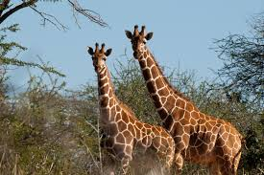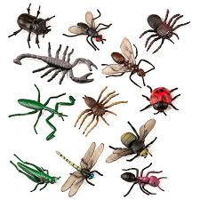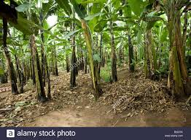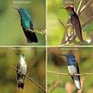

mountains hills lakes rivers

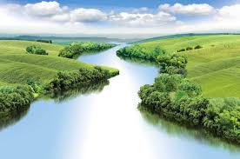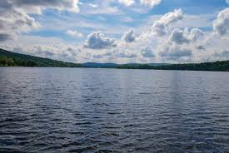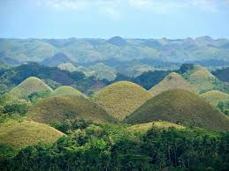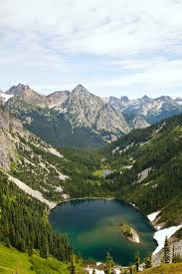

Activity

1. What do we call the study of man and his surrounding?
2. Write Social studies in short.
3. Name any three things around man.

The location of our school

Our school is Mbuya Parents’ School.

It is found in Mbuya village.

Our school is found along Ismail Road.

Our school is found in Mbuya II Parish.

Our school is on a hill called Mbuya Hill.

Our school is found in Kampala District, Nakawa Division.

Activity

1 .On which hill is your school found?

2. Along which road is your school found?

3. Name the place where your school is found.

THEME I ; OUR SCHOOL

SUB THEME I People in our school.

A school

A school is a place where we go to learn.

We come to school to learn.

Our school structure

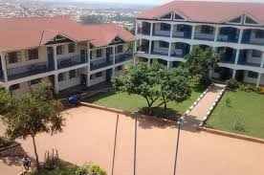

Activity

1. Children will move out and observe our school.

2. What do we call a place where we go to learn?

3. Why do we go to school?

4. Draw your school.

Ways people used to go to school.

by bus by car by van

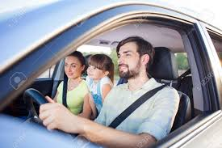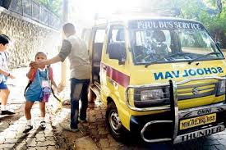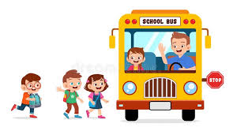

on motorcycle on foot on bicycle

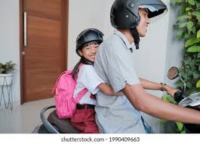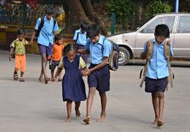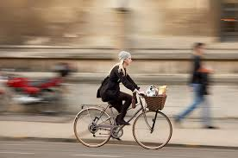

1. How do you come to school?
2. How does this child go to school?

…………………………



Things found on our way to school.

houses trees flowers

birds stones cars

insects animals

Activity

1. Draw these things found on your way to school.

stones car

2. Name any two things found on your way to school.

Dangers on our way to school.

theft kidnapping accidents

bad weather

Activity

1. Underline dangers on your way to school.

kidnapping flowers books accidents

People in our school.

teachers head teacher school nurse

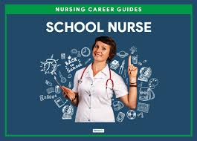

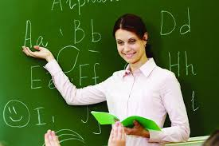



secretary school driver cleaner

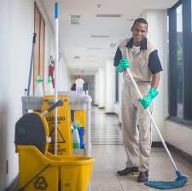

cook gatekeeper night watchman bursar

deputy director librarian pupils matrons

Activity

1. Mention any four people found at school.
2. Draw these people found at school.

teacher school nurse

1. Fill in the missing letterss

dr_ver nu_se

Names of important people in our school

|  |  |
| --- | --- |
| people | name |
| director | Ms.Tushabe Betty |
| head teacher | Mr.Omumwa Richard |
| nurse | Ms.Kyamufumba Winnie |
| librarian | Ms.Sandra |
| bursar | Ms.Salma |
| Deputy head teacher | Mr.Kasasira Samuel |
| class teacher | Tr.Proscovia |

Activity

1. What is the name of your head teacher?
2. Teacher …………… is our class teacher.

People in our school and their work.

1. teacher: teaches pupils.
2. head teacher: heads a school.
3. school nurse: cares for sick pupils.
4. cleaner: cleans the school.
5. secretary: types homework, letters and examinations.
6. gatekeeper: opens and closes the gate.
7. librarian: keeps text books in the library.
8. bursar: collects school fees.
9. cooks: cook food at school.

10.guard: guards people in the school.

Activity

1.Match people to their work.

teacher cares for sick pupils

cleaner types letters

secretary teaches pupils

school nurse cleans the school

2.A ……………….. cooks food at school.

3.Why do we need these people at school?

a) gatekeeper……………………………………..

b) driver……………………………………………..

People in our school and their places of work.

teachers classrooms

cooks kitchen

head teacher office

librarian library

secretary office

school nurse sick bay

gatekeeper gate

bursar office

Activity

1. Identify any three people found at school.
2. Where do we find these people at school?
   1. school nurse………………………………….

b) teacher………………………………………….

3.Identify any two people we find in the office

SUB THEME 2 Things in our school.

Things found in our school.

school flag chairs

flowers chalkboard

bells clock faces

trees tables

brooms books

pens pencils

buildings dusters

swings

Activity

1.Identify any two non living things in your school compound.

2.Draw these things in our school .

flowers bell

3.What is the name of your school?

Play objects in our school

ropes dolls

dolls balls

swings

Activity

1. Mention any two play objects in our school

2. Draw these play objects

balls rope

Buildings in our school.

office toilet/ latrine kitchen

classroom library sick bay

dormitory canteen dining

staffroom

Activity

1. Children will move out to observe buildings in our school

2. Match correctly

classroom secretary

kitchen matron

sickbay librarian

library teacher

dormitory cooks

office nurse

Uses of buildings in our school.

Classrooms - for learning

Office - where the head teacher carries out his or her work.

Library - for keeping school text books.

Toilet/ latrine - for easing ourselves.

Sick bay - where sick pupils are cared ffor

Kitchen - where food is cooked from.

Canteen - where we buy eats.

Boarders sleep in the dormitory.

Activity

1. How are toilets useful at school?

2. Draw these buildings at school.

Kitchen classrooms

3. Who cares for sick pupils at school?

4. Identify any two things found in the dormitory.

5 .Name any two things we can buy from the canteen.

Things in our classroom

pens pencils books

chairs chalk board desks

charts tables brooms

clock face dusters chalkboard rulers

rulers rubber cupboard

Activity

1. Identify any four things found in your classroom.

2. Who heads a class?

3. Draw these things in your classroom.

Chairs ruler brooms

Uses of things in our classroom.

books -for writing in.

pens and pencils - for writing with.

brooms - for sweeping

chalkboard - for writing on.

dustbin - for putting in rubbish.

chairs - for sitting on.

duster - for rubbing the chalkboard.

clock face -for telling time.

cupboard - for keeping books.

Activity

1. What do teachers use to write on the chalkboard?

2. Match correctly

brooms for rubbing the chalkboard

dustbin for telling time

clock face for sweeping

duster for putting rubbish

3.Name any one thing teachers use to teach children.

4.Why do we need chairs in the classroom?

Class rules

Class rules are things that we must obey or follow in our classroom.

Examples of class rules

1. Do all the exercises given.

2. Pay attention to your teachers.

3. Respect teachers

4. Keep the classroom clean.

5. Avoid shouting in the classroom.

6. Put up your hand before you answer.

7. Always write well.

8. Ask permission before you leave the classroom .

Note; We need class rules to keep order in the classroom.

Activity

1. Mention any three class rules.

2. Why do we need class rules?

3. Write the name of your class teacher.

School symbols

School symbols are things that make a school different from others.

Examples of school symbols

School uniform school motto

School badge school prayer

School signpost school name

School anthem school mission

School address school flag

Drawing school symbols

School flag

Our school flag has two colours

White and blue

Our school flag

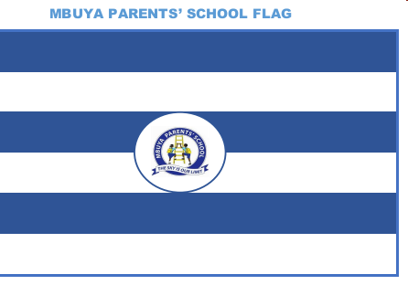

school uniform

Our school uniform is white and blue

It makes pupils look smart

Our school uniform

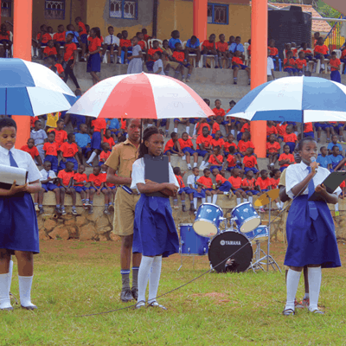

Activity

1. What is the colour of your school uniform?

2. Draw these school symbols.

School flag school uniform

3. Why do pupils put on the school uniform?

4. Write one colour found on your school flag.

School signpost

A school signpost shows the location of the school.

A school signpost

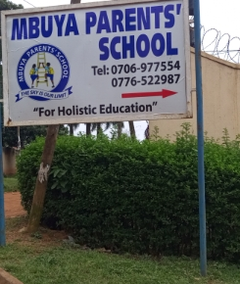

Things found on the school signpost

-school name -school badge

-school address -school motto

The school badge



The school badge is for identification.

Things found on the school badge

-school name -school motto

Our school motto is THE SKY IS OUR LIMIT.

Activity

1. Identify any two things found on the school signpost

2. Name the school symbol below.

…………………………………..



3. What is your school motto?

4. Write your school name.

Uses of school symbols

1.School uniform makes pupils look smart and alike.

2. school signpost shows the location of the school.

3.school badge for identification

4.school motto encourages pupils to work hard.

5. school prayer makes pupils grow God fearing.

Activity

1. Which school symbol shows the location of the school?

2. Give one use of the school badge.

3. Draw a school uniform.

School rules and regulations

School rules are things we must obey or follow at school.

School rules help to keep order at school.

Examples of school rules.

1. Wear the school uniform.

2. Respect teachers and prefects.

3. Come to school early.

4. Speak English at school.

5. Do not fight or abuse others.

6. Do not escape from school.

7. Respond to the bell.

Activity

1. Underline school symbols.

Come to school early.

Fight others

Wear the school uniform

Escape from school

2 .Why do we need school rules?

School needs

School needs are things we need at school.

Examples of school needs.

Money food teachers

Water uniforms brooms

Pencils text books furniture

Buildings chalk play objects

Activity

1.Circle school needs only.

Stones food insects uniforms

2.We need play objects at school. Name any two play objects you know.

3.Draw these school needs

books chalk

Uses of school needs.

1.Money - for buying things like food, chalk ,books

2.teachers - for teaching pupils.

3.classrooms- for learning

4.food - for growth and energy.

5. water - for drinking cooking and washing

Activity

1.Name any two things we buy at school.

2.How is water useful at school?

3.Give any three examples of furniture in your classroom.

4.Why do we need a dust bin at school?

SUB THEME III Activities done at school.

Activities done at school

sweeping teaching playing

reading writing singing

dancing swimming praying

mopping learning running

digging slashing

Activity

1.Identify these activities done at school.

2.What do we use for

a)digging

b)writing

3.Write any two activities done in the classroom.

4.Draw the activities done at school.

running swimming

Ways of keeping the school clean

1.By sweeping the classrooms and compound.

2. By slashing bushes around the school compound.

3.By dusting tables and desks.

4. By mopping classrooms and toilets.

5.By picking rubbish

Activity

1.How can you keep your classroom clean?

2.Where should we put rubbish after picking it?

Things we use to keep the school clean.

brooms slasher rag

hoe water rake

soap

Activity

1.Mention any two things we use to keep the toilet clean.

2.Name the item below used for proper rubbish disposal.

3. Draw these things used to keep the school clean.

rake brooms

Importance of keeping the school clean.

-To prevent diseases.

-To prevent a bad smell.

-To prevent germs.

THEME 2 OUR HOME

SUB THEME 1 People in our home

A home is a place where we live or stay.

Our home

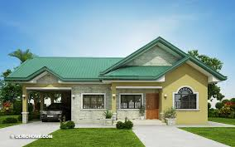

Things that make up a home./ components of a home.

Toilet /latrine kitchen

Bathroom compound

Main house

Activity

1.What do we call a place where we live or stay?

2.Identify any two components of a home.

3. Draw your home.

Things a good home must have.

Rubbish pit kitchen

Drying rack toilet/latrine

Bathroom compound

Note

A drying rack is for drying washed utensils.

A drying rack

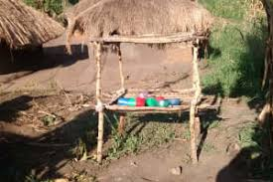

Buildings found in a home.

Kitchen toilet/ latrine

Bathroom granary

A granary is for storing harvested crops.

A granary

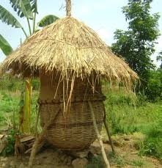

People found at home.

Mother father sister

Brother aunt uncle

Niece nephew grandfather

Grandmother cousin sister cousin brother

Drawing people at home

Activity

1.Give any four people found at home.

Draw these people at home.

Mother brother grandfather

SUBTHEME 2 Roles and responsibilities of family members.

A family

A family is a group of people related by blood, marriage or adoption.

Types of families

Nuclear family

Extended family

Activity

1.What do we call a group of people related by blood, marriage or adoption?

2.Write one type of family.

3.How are children related to their parents?

A nuclear family

A nuclear family is a family where we find parents and their own children,

People in a nuclear family.

Mother father

Sister brother

Activity

1.Identify any two people in a nuclear family.

2.Who heads a nuclear family?

3.Draw and name the missing member in a nuclear family.

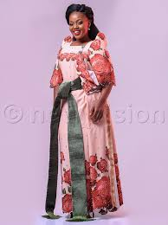

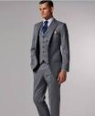

father ……………….. mother

An extended family

An extended family is a family where we find parents, children and their relatives.

Relatives include

Aunt uncle grandmother cousin brother

Niece nephew grandfather cousin sister

Drawing people in an extended family.

Activity

1.Underline people in an extended family.

niece book uncle tree grandmother

2.In which type of family do we find relatives?

3.Draw these people in an extended family.

grandfather grandmother

Roles of people found at home.

|  |  |
| --- | --- |
| father | Buys food  Pays school fees  Buys clothes  Protects the family  Builds the house |
| mother | Breast feeds the baby  Cooks food  Cleans the house  Washes clothes  Takes care of children |
| children | Sweep the compound  Fetch water  Collect firewood  Wash utensils  Carry the baby |

Activity

1.How is a father useful at home?

2.Who breast feeds the baby at home?

3.Give any two roles of children at home.

Basic needs of a family.

Basic needs are things man cannot live without.

Examples of basic needs

|  |  |  |
| --- | --- | --- |
| food | water | shelter |
|  |  | images-21 |
| clothes | Medical care |  |
|  |  |  |

Other needs of man.

education land love

security electricity money

Activity

1. What do we call things which man cannot live without?

2. Identify any two basic needs of man.

3 .Why do we wear clothes?

4. Which basic need makes us grow well?

5. why do we need land?

SUB THEME 3 Things found at home and their uses.

Things found at home

|  |  |  |  |
| --- | --- | --- | --- |
| cups | bed | chairs | knife |
|  |  |  |  |
| kettle | radio | television | saucepan |
|  |  |  | C:\Users\mps\AppData\Local\Microsoft\Windows\INetCache\Content.Word\download-45.jpg |

Uses of things at home

broom: for sweeping

pot: for keeping water

chair: for sitting ons

bed: for sleeping on

hoe: for digging

Knife: for peeling

Saucepan: for cooking food

Activity

1. Why do we need the following things at home.

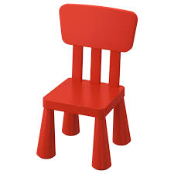

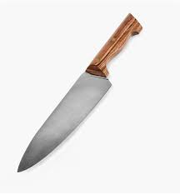

…………………………….. ………………………………….

2. Match correctly

Bed for wearing

Broom for keeping water

Clothes for sleeping on

Pot for sleeping on

A house

A house is a building where people live.

Parts of a house

wall

door

verandah

window

roof

ventilators

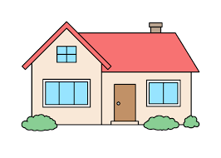

Things a good house must have.

door roof

ventilator window

Activity.

1. What do we call a building where people live?

2. Name any three parts of a house.

3. Identify these parts of a house

……………….. 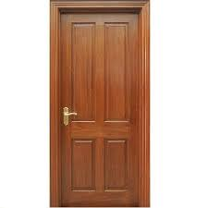 ……………..

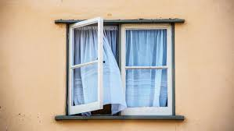

Parts of a house and their uses.

1 door: For entering the house.

2. roof: Protects us from bad weather.

3. window: To let in light and fresh air.

4. ventilator: To allow in fresh air and let out bad air.

Activity

1. Draw these parts of a house.

Door ventilators

2. Which part of a house protects us from bad weather?

3. How are ventilators useful on a house?

Uses of a house

1. A house protects us from bad weather.

2. A house gives us warmth.

3. A protects us from dangerous animals and bad people.

4. People stay in a house.

5. A house protects our property.

Activity

1. Why do people build houses?

2. Write any two property found in a house.

3. Draw a house.

Rooms found in a house.

Kitchen sitting room toilet

Dining room bathroom store

Things found in the kitchen.

|  |  |  |
| --- | --- | --- |
| saucepan | jug | spoon |
|  |  | download-53 |
| kettle | sieve | flask |
|  |  |  |
| charcoal stove | fork | mingling stick |
|  |  | download-73 |

Other things found in the kitchen

Plates cups dishes charcoal knife

Activity

1. Identify any two rooms found in the house.

2. Mention any four things found in the kitchen.

Things found in the sitting room/ living room

|  |  |  |
| --- | --- | --- |
| radio | television | chairs |
|  |  | download-34 |
| table | carpet | table cloth |
| C:\Users\mps\AppData\Local\Microsoft\Windows\INetCache\Content.Word\download-134.jpg | C:\Users\mps\AppData\Local\Microsoft\Windows\INetCache\Content.Word\images-17.jpg | download-74 |

Things found in the bedroom.

|  |  |  |
| --- | --- | --- |
| mattress | Bed sheets | blankets |
| C:\Users\mps\AppData\Local\Microsoft\Windows\INetCache\Content.Word\download-75.jpg | C:\Users\mps\AppData\Local\Microsoft\Windows\INetCache\Content.Word\images-72.jpg |  |
| wardrobe | pillow | bed |
|  |  | download-31 |

suitcase clothes shoes mosquito net dressing mirror

Activity

1. Circle things found in the sitting room.

Pillow chairs bed wardrobe

2. Give any three things found in the bedroom.

Things found in the bathroom

|  |  |  |  |
| --- | --- | --- | --- |
| basin | soap | water | bucket |
|  | C:\Users\bar job\Desktop\download-79.jpg |  | download-80 |
| towel | toothbrush | toothpaste | sponge |
|  |  |  |  |

Things found in the store.

Hoes panga food rake basket brooms

Wheelbarrow slasher hummer

Activity

1. Draw these things found in the bathroom.

Soap toothbrush

2.Match correctly

Bedroom sponge

Sitting room hoe

Store bed sheets

Bathroom television

1. Complete correctly with group names from the bracket.

A ) bed sheets, mattress and blankets are……………………….

b) saucepan, plates, dishes and cups are………………………

c) skirts, dresses, sweaters and shirts are…………………………

(utensils , clothings ,beddings )

Types of houses

There are two types of houses

Permanent houses

Temporary houses

Permanent houses

Permanent houses are houses which last for a long time.

These houses are built using strong building materials.

Examples of permanent houses.

|  |  |
| --- | --- |
| flat | bungalow |
|  | images-21 |

Activity

1. Write the two types of houses.

2. What do we call houses which last for a long time?

3 .Draw these permanent houses.

bungalow flat

Materials used to build permanent houses.

|  |  |  |
| --- | --- | --- |
| cement | bricks | nails |
|  |  | images-22 |
| sand | stones | timber |
|  |  | images-25 |

Iron bars

Activity

1 .Name any three materials used to build permanent houses.

2. Identify these strong building materials.

Temporary houses

Temporary houses are houses which cannot last for long.

These houses are built using weak building materials.

Examples of temporary houses.

|  |  |  |
| --- | --- | --- |
| hut | tent | Mud house |
|  |  | images-27 |
| kiosk | unipot |  |
|  |  |  |

Activity

1. What do we call houses which cannot last for long?

2. Give any two examples of temporary houses.

3. Identify the type of house below.

………………………………………….



Materials used to build temporary houses.

|  |  |  |
| --- | --- | --- |
| grass | reeds | poles |
|  |  | C:\Users\mps\AppData\Local\Microsoft\Windows\INetCache\Content.Word\download.jpg |

Sticks, soil

Activity

1. Circle weak building materials.

Soil, sand , timber , reeds

2. What is the roof of a hut made of?

3. Draw these weak building materials.

Grass reeds

Sources of building materials.

building materials source

Stones stone quarry

Timber forest

Sand lakes

Nails, iron bars, cement factory

Grass, sticks bush

Activity

1. Where do people get stones?

2. Which building material is got from the forest?

3. Name any two building materials got from the factory.

Activities done at home.

Cooking slashing sweeping

Digging washing peeling

Pounding grazing mopping

Grinding ironing milking

|  |  |  |
| --- | --- | --- |
| pounding | slashing | milking |
|  |  | C:\Users\mps\AppData\Local\Microsoft\Windows\INetCache\Content.Word\download-1.jpg |
| grinding | grazing | cooking |
|  |  | download-95 |

Ways of keeping our home clean.

1. By slashing tall grass.

2. By mopping the house

3. By sweeping the compound and the house.

4. By picking rubbish.

5. By weeding flower gardens.

6. By smoking pit latrines.

Activity

1. How can you keep your home clean?

2. Where should we put rubbish after picking it?

3. What do we use to sweep the compound?

Things we use to clean our home.

|  |  |  |
| --- | --- | --- |
| broom | water | rake |
|  |  | download-98 |
| hoe | slasher | soap |
|  | C:\Users\mps\AppData\Local\Microsoft\Windows\INetCache\Content.Word\images-4.jpg | download-79 |

Rag scrubbing brush

Examples of places which must be kept clean at home.

Compound bathrooms sitting room

Kitchen bedroom toilet/latrine

Reasons why we need to keep our homes clean.

1. To prevent diseases.

2. To prevent germs.

3. To prevent a bad smell.

Activity

1. Name any three things used to keep the home clean.

2. Identify any two places which must be kept clean every day.

3. Why do we keep our home clean?

Animals kept at home.

Animals kept at home are called domestic animals.

Examples of domestic animals

|  |  |  |
| --- | --- | --- |
| cow | Dog | pig |
|  |  | download-106 |
| sheep | Cat | donkey |
|  |  | download-110 |
| goat | Rabbit | camel |
|  |  | download-112 |

Horse ox

Activity

1. What do we call animals found at home?

2. Cirle domestic animals only.

Snake, cow, lion, zebra, horse

3. Draw these domestic animals

Cat goat

Uses of domestic animals.

1. People sell animals and get money.( for income)

2. Dogs guard our homes.

3. Cats and dogs are kept as pets

4. Cats chase away rats from our homes.

5. We get milk and meat from cows and goats.

6. We use animals like horses, camels for transport.

7. The oxen are used for ploughing.

8. Sheep gives us wool and mutton.

Activity

1. Why do we keep cows at home?

2. Identify the domestic animal that provide us with wool and mutton.

3. Which animal is used for ploughing?

4. Name the animal which protects us from thieves.

5. We get………………………and……………………………from cows.

6. Name any two pet animals.

Animal products

Animal products are things we get from animals.

Examples of animal products

Meat milk skin

Horns hooves wool

Animals and their meat

Animal meat

Cow beef

Sheep mutton

Pig pork

Fish fillet

Hen chicken

Activity

1. Name any two animal products.

2. Circle animal products that we can eat.

milk, horns , skin , meat

3. Match animals to their meat.

pig beef

sheep fillet

cow pork

fish mutton

Ways of caring for domestic animals.

1. By giving animals food.

2. By giving animals water.

3. By cleaning their shelter.

4. By treating animals when they are sick.

5. By building for animals shelter.

Activity

1. How can you care for animals at home?

2. Underline ways of mistreating animals.

By beating animals by feeding animals by killing animals

THEME 3 OUR COMMUNITY

SUB THEME 1 People in our community

A community

A community is a group of people living or working together.

Examples of communities

school community home community

hospital community market community

village community church community

mosque community

Note: A home is the smallest community.

Activity

1. What do we call a group of people living or working together?

2. Give any three examples of communities.

3. Identify any two people found in these communities

a) school community ……………………. ……………………

b) church community …………………….. ……………………

c) home community ……………………… …………………...

4. What is the smallest community?

People in our community

|  |  |  |
| --- | --- | --- |
| teacher | policemen | doctors |
| C:\Users\mps\AppData\Local\Microsoft\Windows\INetCache\Content.Word\download-4.jpg |  | C:\Users\mps\AppData\Local\Microsoft\Windows\INetCache\Content.Word\images-3.jpg |
| drivers | nurse | fishermen |
|  |  | download-119 |

Builders tailors pilots cobblers butcher

Barbers farmers fish mongers shopkeepers carpenter

Religious leaders mechanics electricians market vendors

Activity

1. Mention any four people found in the community

2. Underline people found in the market community

doctors , hawkers , teachers , market vendors

3. Draw these people in the community

Farmer builders

People found in the community and their work.

1. A carpenter makes furniture.

2. A cobbler mends shoes.

3. A barber cuts hair.

4. A mechanic repairs cars.

5. A doctor treats sick people.

6. A tailor mends clothes.

7. A fish monger sells fish.

8. A police man keeps law and order.

9. A butcher sells meat.

10. Religious leaders preach the word of God/ Allah.

Activity

1. Who keeps law and order in our community?

2. Why do we need a carpenter in our community?

3. Match correctly

cobbler sells meat

barber mends clothes

butcher mends shoes

tailor cuts hair

People in the community and their places of work.

People places of work

doctors hospital/ clinic

police men police station

market vendors market

Shop keepers shop

Mechanic garage

Carpenter work shop

Butcher butcher’s shop

Barber barber’s shop

Farmer garden/farm

Activity

1. Where do we find these people in the community?

a) mechanic…………………….

b) doctors ……………………..

2. Name any two examples of religious leaders.

3. Identify any two places where we can go for treatment.

People in the community and their tools.

teachers chalk

policemen gun

farmer hoe

fishermen fishing net

SUB THEME 2: Activities in the community.

Activities done in the community.

|  |  |  |
| --- | --- | --- |
| farming | teaching | driving |
|  | C:\Users\mps\AppData\Local\Microsoft\Windows\INetCache\Content.Word\download-4.jpg | download-117 |
| building | fishing | carpentry |
|  |  |  |

Mining brick making

Activity

1. Name any three activities done in the community.

2. Which activity is done to get food?

3. Match people in the community to their activities.

teacher fishing

driver building

carpenter driving

farmer teaching

fisher men carpentry

builder farming

Cultural activities in the community.

Cultural activities are activities done to celebrate things in one’s tribe.

Circumcision tattooing

De toothing marriage

Naming children

Activity

1. Which tribe circumcise boys?

2. Circle cultural activities only.

Building, marriage, fishing, naming children

SUB THEME 3: Important places in the community

Important places found in the community.

|  |  |  |
| --- | --- | --- |
| Church | market | Police station |
|  |  | images-63 |
| Mosque | hospital | school |
|  | C:\Users\mps\AppData\Local\Microsoft\Windows\INetCache\Content.Word\images-2.jpg | C:\Users\mps\AppData\Local\Microsoft\Windows\INetCache\Content.Word\download-3.jpg |

Post office, radio station, bank, shops, hotels

Activity

1. Mention any three important places in the community

2. Draw these important places.

church school

3. Write out people we find in the church.

doctor pastor barber ……………………..

teacher Bishop Imam ………………………

Uses of important places

1. school: Where we go to learn.

2. shops: Where we buy things.

3. bank: Where we keep our money.

4. hospital: Where we get treatment.

5. church: Where Christians go for prayers.

6. post office: Where we send and receive letters.

7. market: Where we buy food.

8. police station: Where we report and take bad people.

9. mosque: Where Moslems go for prayers.

10. petro station:Where we buy fuel.

End of term one